Update Resources in SF from SharePoint
- Open the link : https://footlocker.sharepoint.com/sites/HRIS
- Go to Training > HR Systems Training Materials

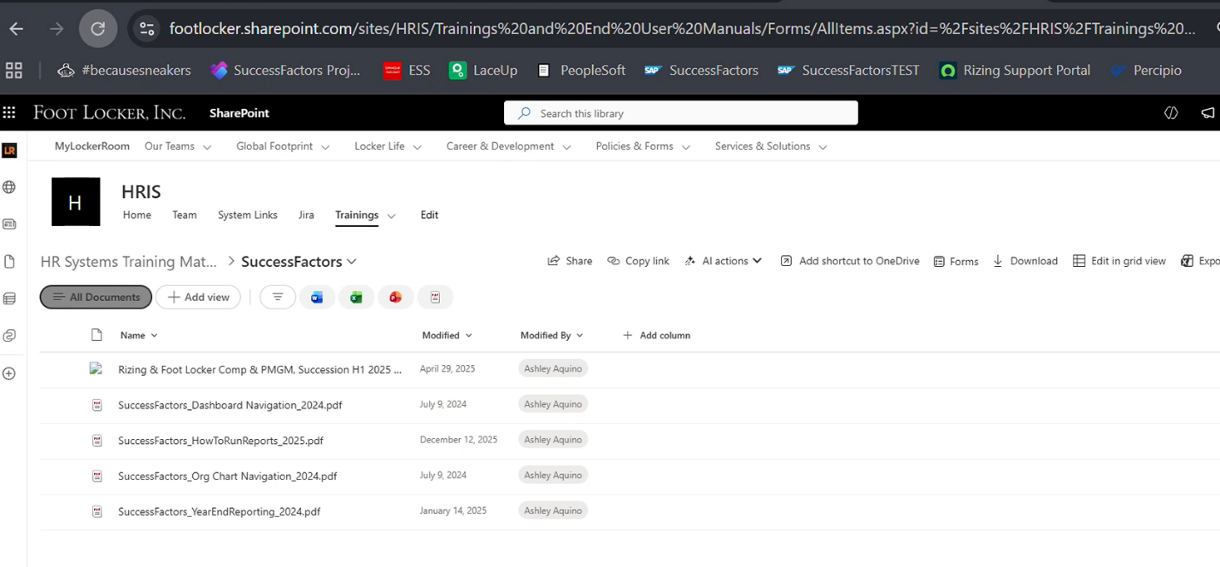

- Delete the old links
- Upload the new link by clicking upload button on the RHS
- 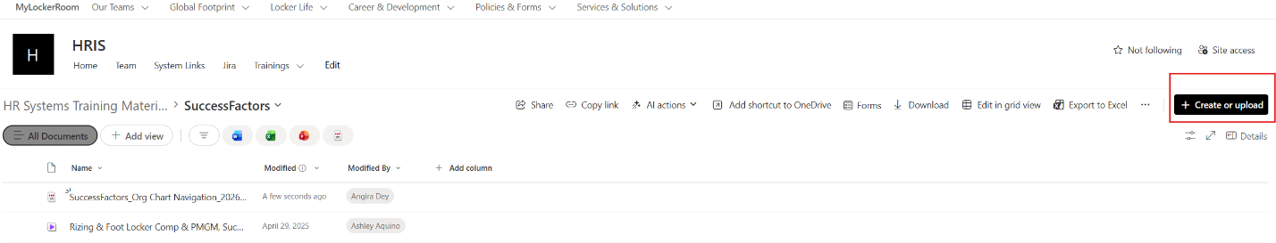
- Open SF Production > Go to Resources on the Home Page >Update Company Resources >SuccessFactors Overview

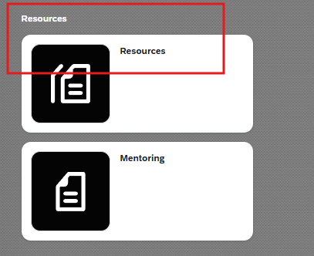
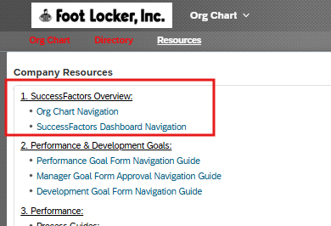

8.Click on the link you want to update > click on the link icon>update the URL with the new link from the SharePoint site > Update the Target to 'New Window' >click Ok and Done
